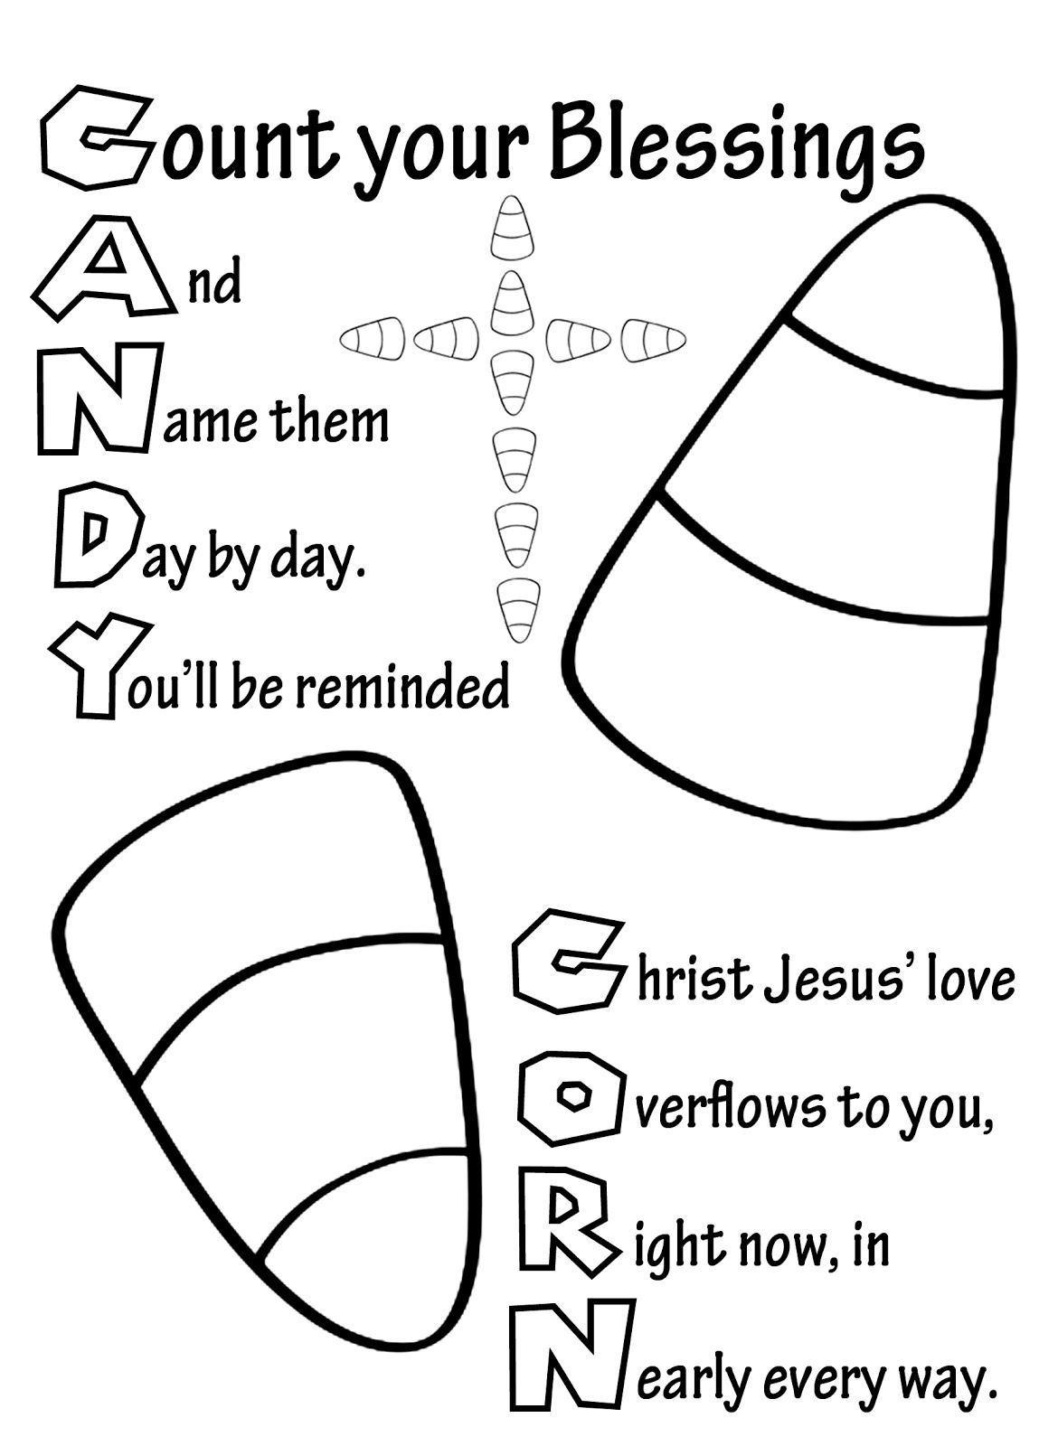

**www.LifeAtTheCrossroads.com**